St. Joseph’s Anglo-Chinese School
Form 6 English Language
Paper 4 Speaking – Exam Practice (DSE 2023 Set 2.1)

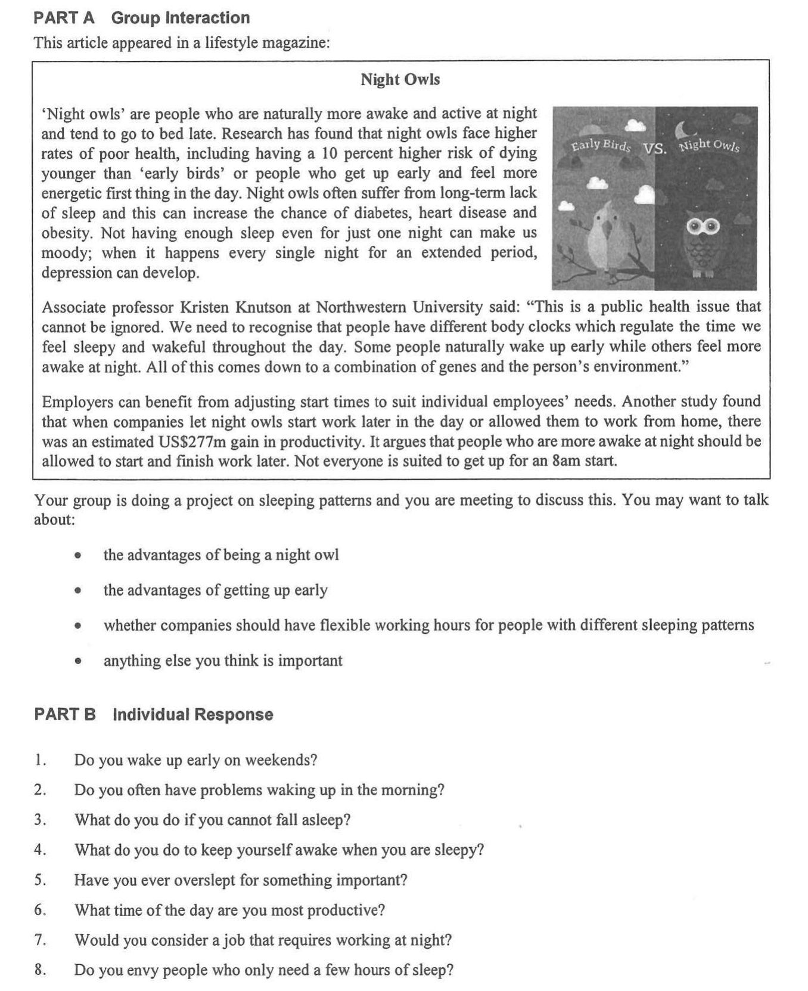

Warm-up – Two Easier Part B Questions (6 minutes, in pairs)
Both partners answer the same question. Push for a time, a reason and one detail — not a one-word answer. This is where you hear their Level 3 baseline.
Question 1 | Do you wake up early on weekends? | What to listen for
Model answer | On school days I get up at 6:30, but at the weekend I sleep until 10 or 11 — I am catching up on sleep. | Times, a comparison, and whether they connect it to the sleep they lost
Question 2 | Do you often have problems waking up in the morning?
Model answer | I often have problems waking up because I burn the midnight oil on my phone, so my concentration is impaired in the first two lessons. | The reason behind the problem: homework, phone, gaming, part-time job, noisy home

▸ Upgrade opportunity — take what they say and lift it
“What I usually say” | Upgrade (useful for Part A and Part B) | Where it pays off
“I always stay up late.” | I burn the midnight oil most nights. | Any health or habit answer
“I am very tired in the morning.” | I am sleep-deprived, so I suffer from daytime drowsiness. | Part B Q1, Q2
“I sleep more at the weekend.” | I try to catch up on sleep at the weekend. | Part B Q1
“I can’t think in the morning.” | My concentration peaks late at night, but not in the morning. | Part A bullet 1, Part B Q6

Part A – The Discussion Task (10 min preparation, 8 min discussion)
Your group is doing a project on sleeping patterns and you are meeting to discuss this. You may want to talk about: the advantages of being a night owl; the advantages of getting up early; whether companies should have flexible working hours for people with different sleeping patterns; anything else you think is important.
▸ Say it another way — synonyms to replace the question’s own wording
Students who recycle the paper’s words score lower than students who paraphrase. Put these on the board and ban the left-hand column.
The question says… | Say instead | Model sentence
advantages | benefits · the upside · what works in its favour · the main plus | The main benefit of being a night owl is the quiet late-night hours.
being a night owl | having a late chronotype · being an evening type · a late riser | People with a late chronotype are not lazy — their body clock runs later.
getting up early | being an early riser · a morning person · starting the day at first light | Early risers get first choice of the quiet morning slots.
companies should have flexible working hours | employers ought to offer flexitime · staggered start times · core hours with flexible ends | Employers ought to offer staggered start times instead of one fixed 8 a.m. bell.
different sleeping patterns | different body clocks · individual chronotypes · people’s natural sleep–wake cycles | A one-size-fits-all timetable ignores people’s natural sleep–wake cycles.
anything else you think is important | one thing often overlooked · what also matters here · a further consideration | One thing often overlooked is that most of the risk comes from habits, not genes.

Ideas for the Note Grid – 3 Noun Phrases per Question, with a Model Example
Give the noun phrase first (it is what they write in the grid), then the model example (it is what they say). The three points in each set are deliberately different in kind, so a group cannot make the same point three times.
1. the advantages of being a night owl
• a genuine late-night mental peak | e.g. Their body clock is inherited, so they really are sharpest after dark — when my concentration peaks, the house is quiet and I finally get chapters read.
• uninterrupted late hours | e.g. After 10 p.m. there are no messages, no chores and no noise, so the work gets done in half the time.
• a natural fit with modern work | e.g. Online, freelance and global work often runs late, and night owls can talk to people in other time zones while everyone else is asleep.

2. the advantages of getting up early
• head start on the day | e.g. Morning people get the revision slot, the empty gym and the quiet library before anyone else is up.
• peak alertness when exams happen | e.g. Public exams and listening papers are held in the morning — early birds are already awake for the paper that counts.
• a calmer, better-prepared start | e.g. There is time for breakfast and a last look at notes, so nothing is forgotten and nobody runs for the bus.

3. whether companies should have flexible working hours
• measurable gains in output | e.g. When night owls were allowed to start later or work from home, the study estimated a US$277m gain in productivity.
• a better match between the person and the timetable | e.g. Flexitime with a few core hours lets each employee work at their own chronotype while the team still meets in the middle of the day.
• fair limits that must be admitted | e.g. Not every job can flex — nurses, drivers, teachers and 24-hour shop staff work in shifts, so the policy cannot be for everyone.

4. anything else you think is important
• habits that can be changed | e.g. Most of the extra heart risk came from smoking, poor sleep and diet — not from the body clock itself, so it is not a life sentence.
• a school start time that fits teenage biology | e.g. A 15-minute later start improved students’ feelings about their sleep, and 86% of students and 95% of teachers welcomed it.
• a health issue, not a character flaw | e.g. The professor in the article calls it a public health issue that cannot be ignored — so we should stop calling night owls lazy.

Part B – Individual Response: Questions 7 and 8 (1 minute each)
Q7. Would you consider a job that requires working at night?
3 noun-phrase ideas | Model example
• a good match with my body clock | I am an evening type, so I would be at my sharpest at 2 a.m. instead of half-asleep at 8 a.m.
• practical rewards and fewer interruptions | Night shifts are quieter and usually pay a shift allowance, which helps while I am still studying.
• a serious long-term health cost | As a career it would take a toll on my health, because sleeping through daylight causes sleep deprivation and cuts me off from family and friends.

▸ Upgrade opportunity for Q7
“What I usually say” | Upgrade | Why it scores
“Night work is bad for you.” | Long-term night work takes a toll on your health. | Names the cost precisely
“I like working at night.” | I am an evening type, so my productivity peaks late at night. | Ties the answer to chronotype
“I would try it for a while.” | On balance, I would try it short-term, but the trade-off is a sleep deficit I could not sustain. | Balanced conclusion with weighing language
Q8. Do you envy people who only need a few hours of sleep?
3 noun-phrase ideas | Model example
• the appeal of extra hours | They seem to be handed two extra hours a day — time for revision, a part-time job and their hobbies.
• the hidden cost of short sleep | Most people who claim to need four hours are actually sleep-deprived, and it impairs their concentration and memory — the two things students need most.
• a misconception that short sleepers are fine | People assume a short sleeper needs less sleep, but the evidence suggests they are simply running a sleep debt — that is the common misconception.

▸ Upgrade opportunity for Q8
“What I usually say” | Upgrade | Why it scores
“They are lucky.” | I used to envy them, but the evidence suggests they are running a sleep debt. | Concedes first, then counters
“I forget things when I am tired.” | When I am sleep-deprived, my cognitive performance is impaired. | Formal, precise vocabulary
“Sleeping more is better.” | The trade-off is clear: five broken hours may look efficient, but they cost me the next day’s lessons. | Sets up the balanced ending

