St. Joseph’s Anglo-Chinese School
Form 6 English Language
Paper 4 Speaking – Exam Practice (DSE 2023 Set 2.1)

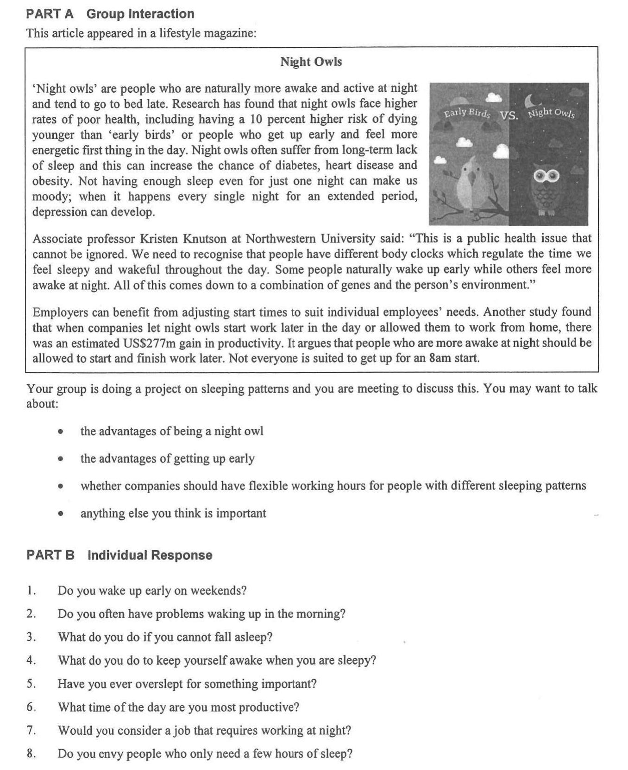
Note Grid – Your Notes for the Discussion
1. the advantages of being a night owl | 2. the advantages of getting up early
3. whether companies should have flexible working hours for people with different sleeping patterns | 4. anything else you think is important

Note Grid – Your Notes for Part B Individual Response Questions
Question: ___________ | Question: _____________

