St. Joseph’s Anglo-Chinese School Name: ____________________ ( )
Form 6 English Language | Paper 4 Speaking – Exam Practice (DSE 2023 Set 2.1 · Night Owls)
Lesson 3 – Night Owls • Student Handout

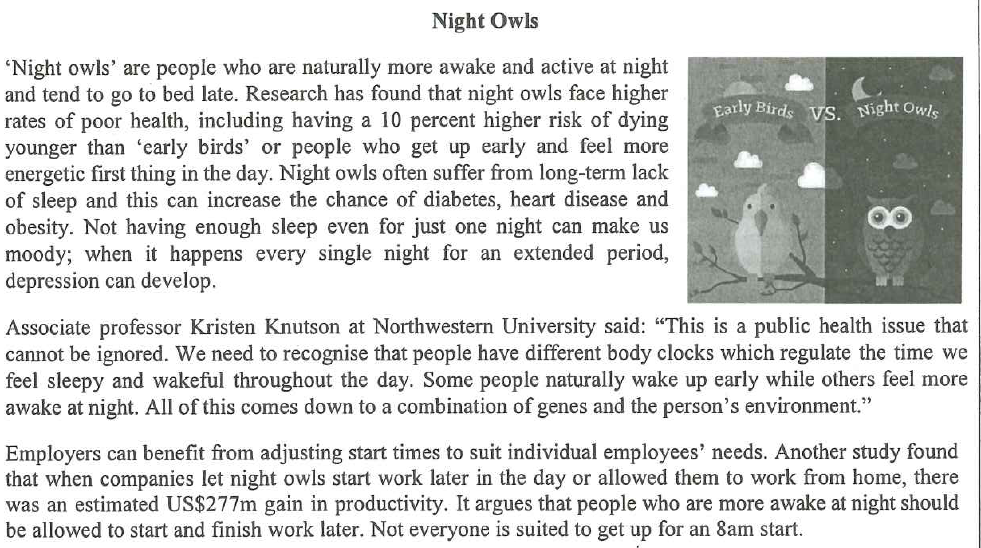
Your group is doing a project on sleeping patterns and you are meeting to discuss this. You may want to talk about:
- the advantages of being a night owl
- the advantages of getting up early
- whether companies should have flexible working hours for people with different sleeping patterns
- anything else you think is important

PART B Individual Response
The examiner will ask you one or more questions based on Part A. You will have up to 1 minute to respond.

VOCABULARY – Level up your language
These 10 expressions will lift your speaking to Level 4 and above. Each one replaces a simple (Level 3) phrase that you would normally use.
STEP 1 Match each expression with its meaning. Write the letter (A–J) on the line.
1. sleep deprivation ______ | A. the fixed hours in the middle of the day when every employee must be at work
2. sleep-deprived (adj) ______ | B. not getting enough sleep, especially over a long period of time
3. to burn the midnight oil ______ | C. to sleep longer in order to make up for the sleep you have lost
4. to catch up on sleep ______ | D. your natural body clock – the times of day when you feel most awake
5. to take a toll on your health ______ | E. to stay up late to study or work
6. to impair your concentration ______ | F. so tired from lack of sleep that you cannot think clearly
7. daytime drowsiness ______ | G. a system that lets employees choose, within limits, when to start and finish work
8. chronotype ______ | H. to slowly damage your health over time
9. flexible working hours (flextime) ______ | I. feeling sleepy during the day, even after you have woken up
10. core hours ______ | J. to make it harder for you to think or focus (formal)

STEP 2 Now look at the upgrade. Instead of the Level 3 phrase, use the Level 4+ expression:
Level 3 – what we usually say | Level 4+ – use this instead | Use it for
“not getting enough sleep” | sleep deprivation | A
“very tired” | sleep-deprived (adj) | A
“stay up late to study” | to burn the midnight oil | A
“sleep more at the weekend” | to catch up on sleep | A
“be bad for your health” | to take a toll on your health | A
“make it hard to focus” | to impair your concentration | A
“feel sleepy in class” | daytime drowsiness | A
“the time your body likes to sleep” | chronotype | A
“choose your own working hours” | flexible working hours (flextime) | C
“the hours when everyone must be at work” | core hours | C
Use it for: A = any health / sleep-cost answer, including Part B · C = the flexible-working-hours bullet and Part B Q1
Challenge: use at least three of these expressions in your Part A discussion.

NOTE CARD
• the advantages of being a night owl: | • the advantages of getting up early:
• whether companies should have flexible working hours for people with different sleeping patterns: | • anything else you think is important:

